[DOI: 10.30644/rik.v14i1.951](https://doi.org/10.30644/rik.v7i1.218)

# Comporative analysis of banana pseudostems and banana stems as adsorbents for reducing peroxide content and free fatty acids (FFA) in used cooking oil

# Eliza Fitria, Betty Nia Rulen*, Carles, Nopianto

STIKes Tengku Maharatu Pekanbaru, Riau

*Corresponding author’s email: bettynia2606@gmail.com

Accepted: 27 January 2025; revision: 30 January 2025; published: 31 January 2025

**ABSTRACT**

**Background**: the increasing production and consumption of palm oil in Indonesia have led to arise in used cooking oil (UCO), classified as hazardous waste due to its high content of free fatty acids (FFA) and peroxides, which are toxic and difficult to degrade. To address this, the use of natural adsorbents such as banana pseudostems and banana stems has gained attention due to their cellulose content, which can effectively absorb harmful compound like FFA and peroxides, improving UCO quality.

**Method**: This experimental study employed a pre-experimental design with a one-group pretest-posttest approach to evaluate the effectiveness of banana pseudostem and banana stem powder, of different mesh size (60, 100, and 200 mesh), in reducing FFA and peroxide levels in UCO. Samples of UCO were obtained from a street food vendor, while the banana plant (Musca acuminata) were collected locally. After immersing the adsorbents in UCO for 72 hour, FFA and peroxide values were analyzed using titration methods. Statistically analysis was performed using a Paired Sample T-Test.

**Results**: The results showed a significant reduction in FFA levels, with the mopst effective reduction observed with 200-mesh adsorbents, where the FFA content decreased from 0.67% to 0.16% for psedostem adsorbent and to 0.20% for stem adsorbents. Peroxide levels were also reduced, with the stem adsorbent reducing peroxide values from 49.60mg/L to 12.92 mg/L, while pseudostem adsorbent reduce it to 14.61 mg/L. Statistical analysis confirmed a significant reduction in FFA (p=0.03), but the reduction in peroxide values was not satistically significant.

**Conclusion**: the particle size of banana pseudostem and banana stem significantly influences the effectiveness of reducing peroxide and FFA levels in UCO. Adsorbents with a particle size of 200 mesh were most effective, with banana pseudostems performing slightly better than banana stems. This study high light the potential of banana plant material as inexpensive and environmentally friendly adsorbents for UCO management.

**Keywords**: Adsorbents; Peroxide; FFA; Banana Stem; Banana Pseudostem; Cooking Oil

**INTRODUCTION**

Used cooking oil (UCO) is a significant environmental concern, particularly due to its hazardous nature and difficulty in degradation. The growing pal oil production in Indonesia, which increased from 37.97 liters per capita per year in 2016 to 49.71 liters in 2021, directly contributes to the rising amount of UCO waste (1).

This surge in production and consumption has resulted in significant used cooking oil waste, which poses environmental challenge due to it hazardous nature and difficulty in degradation (2).

The disposal of UCO is problematic because it contains harmful substances, including high levels of saturated fatty acids and peroxide compounds, which are toxic and difficult to degrade naturally (3)(4).

UCO is classified as hazardous waste (B3) due to its chemical compotition, particularly the formation of free fatty acids (FFA) and peroxides during repeated use (5). These compounds are free radicals that can pose health risks, making UCO unsuitable for direct disposal into the environment (6). Therefore, there is a need for effective treatments, such as refining processes, to purify UCO by removing harmful compounds like FFA and peroxides (7).

One promising solution is the use of environmentally friendly adsorbents for the purification of UCO. Adsoption is an effective method for removing impurities, as adsorbents with smaller particles offer larger surface areas, allowing for greater absorption (8).

There are various types of adsorbents that potential to be used in the purification of UCO, such as sugarcane bagasse, activated charcoal banana peels and banana stems (9).

Banana stems, an underutilized part of the banana plant, can be used as an adsorbent for treating UCO. Despite Indonesia being one of the largest banana producers, banana stems are typically discarded or used as animal feed or for making rafts. They are also used in food applications as well as non-food uses like wastewater treatment, biofertilizers, textiles, and composites materials (10)(11). However, this study will use adsorbents from banana plants, as banana are easily available and produce fruit only one, which may lead to the accumulation of banana plant waste if not properly managed.

Banana stems contain cellulose, which can be used as an adsorbent for absorbing FFA with the addition of activator substances (12). The chemical composition of banana stem fiber consisted of 5-10% lignin, 60-65% cellulose, 6-8% hemicellulose, and 10-15% water. The highest potential lies in the cellulose, which can be used as an adsorbent material (8).

Similarly, the cellulose in the banana stem can bind to harmful compounds such as FFA and peroxides, thus improving the quality of used cooking oil. Additionally, the adsorptive effectiveness of banana stems can influence by factors such as particle size, with smaller particles providing greater surface area for adsoption (13). Therefore, both banana stems and pseudostems present a promising alternative to synthetic adsorbents for the purification of peroxides and FFA in used cooking oil.

This research aims to compare the effect of adsorbent size from banana pseudostems and banana stems on the reduction of FFA and peroxide levels in UCO. By utilizing banana stems, an easily accessible and abundant reasource, this study seeks to provide an environmentally friendly and sustainable alternative to synthetic adsorbents in UCO purification.

**METHOD**

This study is experimental in nature, employing a Pre-experimental research design with a one-group Pretest-posttest approach. In this design, a pretest is conducted before applying the treatment. The research aims to determine the effectiveness and comparison of FFA and peroxide values in used cooking oil before and after treatment by immersing it with banana stem and banana pseudostem powder of varying mesh sizes using mesh size of 60, 100 and 200.

**Preparation of adsorbent samples**

This research was conducted by collecting used cooking oil samples form a street food vendor selling pecel lele around Jalan Tuanku Tambusai, while samples of banana pseudostems and banana stems were obtained from areas near the researcher’s residence with the species Musca acuminata is abundant.

The samples of banana stems and pseudostems were cleaned thoroughly to remove any dirt or impurities. Afterward, the samples were dried at varying temperatures to determine the effect of drying temperature on the adsorbent’s efficacy. The drying process was carried out at temperatures of 40°C, 60°C, and 80°C, and the samples were left to dry for 24 hours. The dried materials were ground into powders, which were sieved into mesh size 60, 100 and 200 microns to test the influence of particle size on the adsorption process.

**Adsoroption Process and Variable Control**

During the adsorption process, several variables were carefully controlled to ensure reliable results. The immersion time was 3x24 hours with a consistent oil volume of 100 mL was used for all trials to maintain uniformity in the experiment. The adsorbent mass was kept constant at 10 grams per trial to ensure that the only variable influencing the results was the type of adsorbent and it mesh size.

**Analysis Method Validation**

To ensure the accuracy of the FFA and peroxide value measurements, the analysis methods were validated through repeat titration tests. For each sample, titration was performed in duplicate, and the average values were used for further analysis. The repeat tests helped to confirm the consistency and reliability of the titration procedure, providing confidence in the results.

**Statistical Analysis**

Data analysis was conducted after completing the laboratory research. The effectiveness of the adsorbents in reducing FFA and peroxide values was evaluated using bivariate analysis with the Paired Sample T-Test (dependent sample T-Test). This statistical test was chosen because it allows for the comparison of two related samples—in this case, the FFA and peroxide values before and after the treatment. The paired design ensures that the variability within each sample is accounted for, providing a more accurate measure of the adsorbent's effectiveness.

**RESULTS**

The procedure testing in this research was conducted at the Chemistry Laboratory of Riau University in August 2023 until Februari 2024.

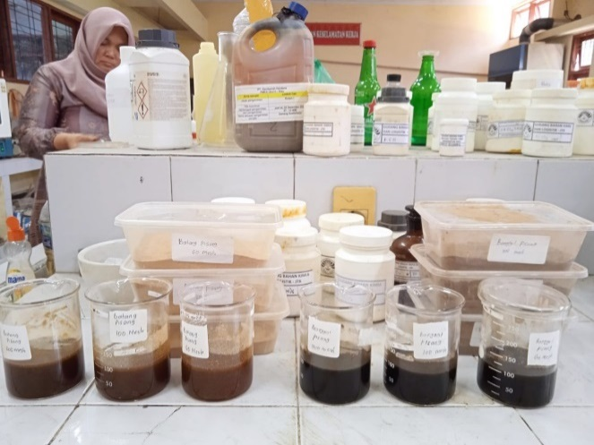

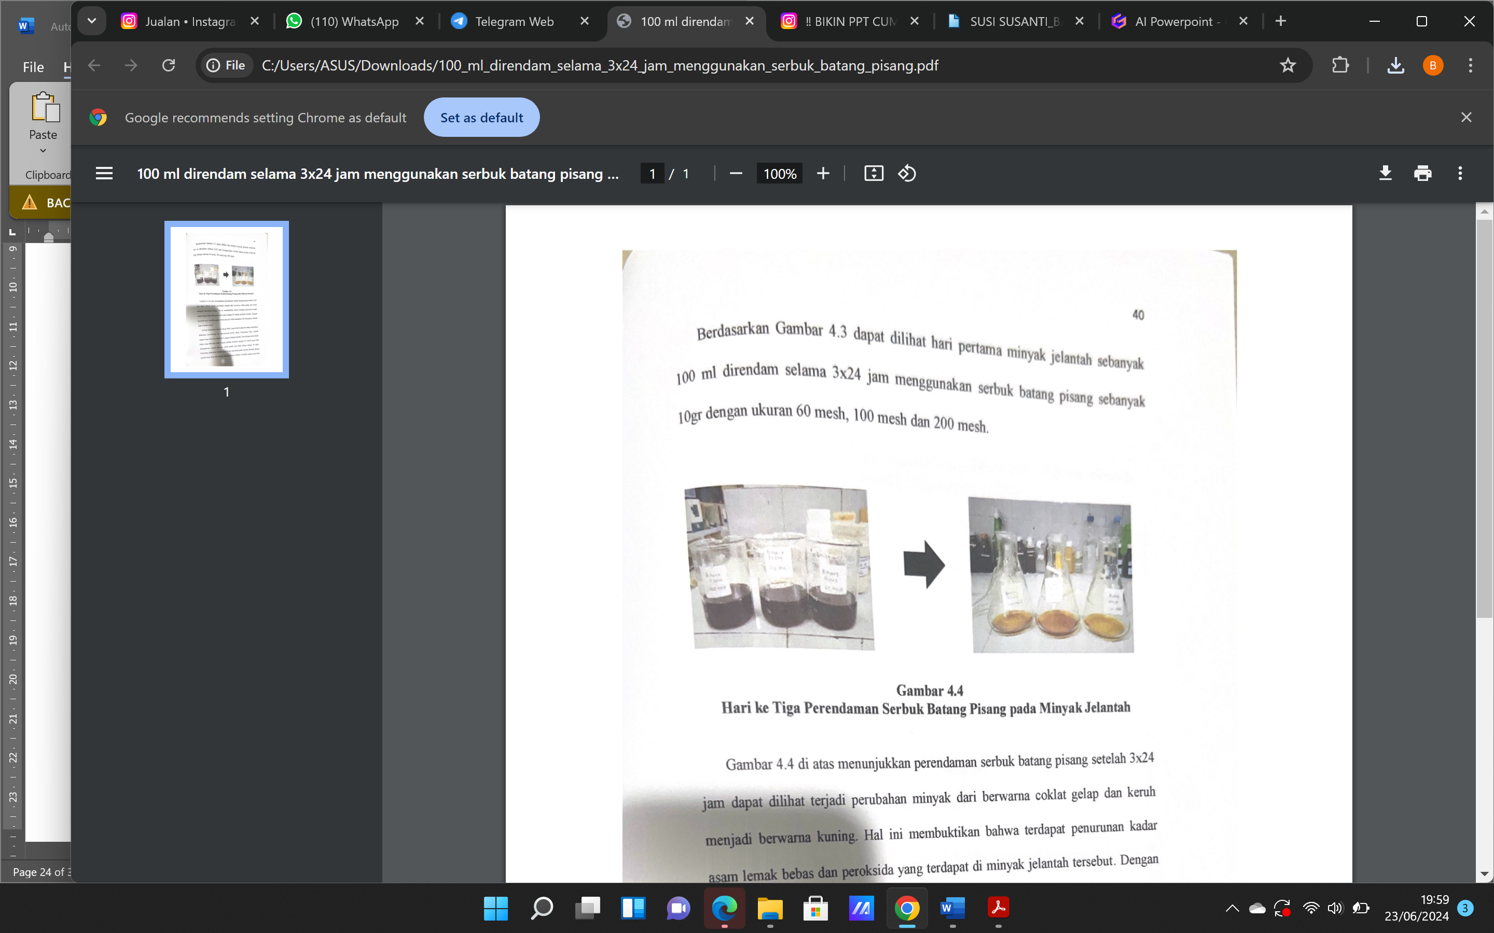

**Figure 1.** Results of Immersion Using Banana Pseudostems and Banana Stems

The banana pseudostems and banana stems were blended into powder to achieve the desired particle size. Before blending, the pseudostems and stems were cut into small pieces and sun-dried for one week. Sieving was performed using mesh size of 60, 100 and 200 to obtain banana pseudostems and banana stems powders of uniform sizes. The powders were then immersed in used cooking oil for 72 hours (3x24 hours). After the 72-hour immersion, the following results were obtained :

Figure 1 shows that immersing used cooking oil with banana pseudostems and banana stems powder resulted in a physical change, as the color of the oil transformed form dark brown to yellowish-brown. This indicates a reduction in free fattt acid (FFA) content and peroxide value in the used oil. The theory suggests that darker oil signifies a higher degree of rancidity and damage.

After the adsorption preocess using banana pseudostem and banana stem powders, the FFA content and peroxides value were measured. A total of eight used cooking oil samples were analyzed. The FFA content was measured by titration with 0.1 NaOH standardized until a persistent pink color appeared for 30 seconds. The peroxide value was analyzed using a titration method with sodium thiosulfate solution until the blue color diasspeared.

The research results, which compared the samples with treatment and without treatment, show a significant difference, as can be seen in the graphic 1 and graphic 2 :

The research results shown in Graph 4.1 indicate a significant reduction in FFA after immersion using banana pseudostem and banana stem pwders with different mesh sizes. The most effective mesh size for reducing FFA was mesh 200, where the initial FFA content of 0.67% dropped to 0.16% with pseudostem adsorbnets and to 0.20% with stem adsorbents.

The analysis of peroxide value absorption revealed that the banana adsorbent was the most effective, reducing the initial peroxide value form 49.60 mg/L to 12.92 mg/L with a mesh size of 200. In contrast, the pseudostem adsorbent reduced the peroxide value to 14.61 mg/L after 72 hours of immersion.

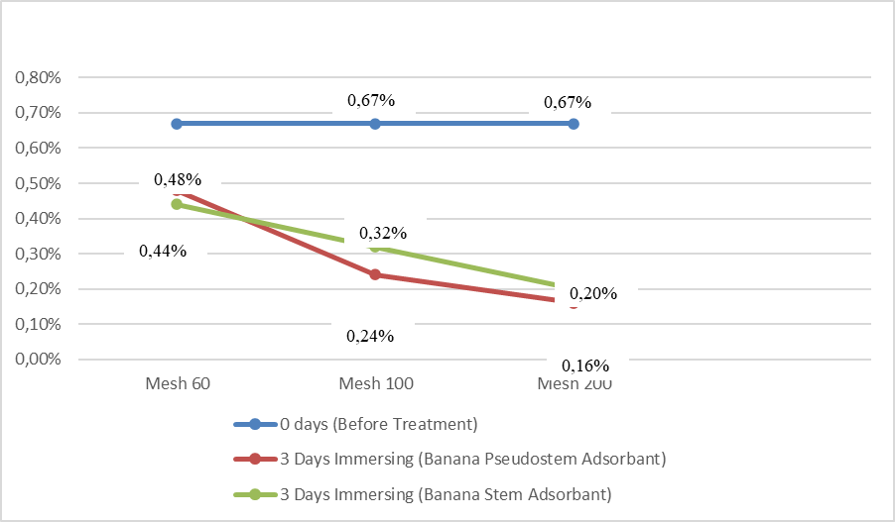

**Graphic 1.** Results of Free Fatty Acid Absorption in Used Cooking Oil with Banana Pseudostem and Banana Stem Adsorbents

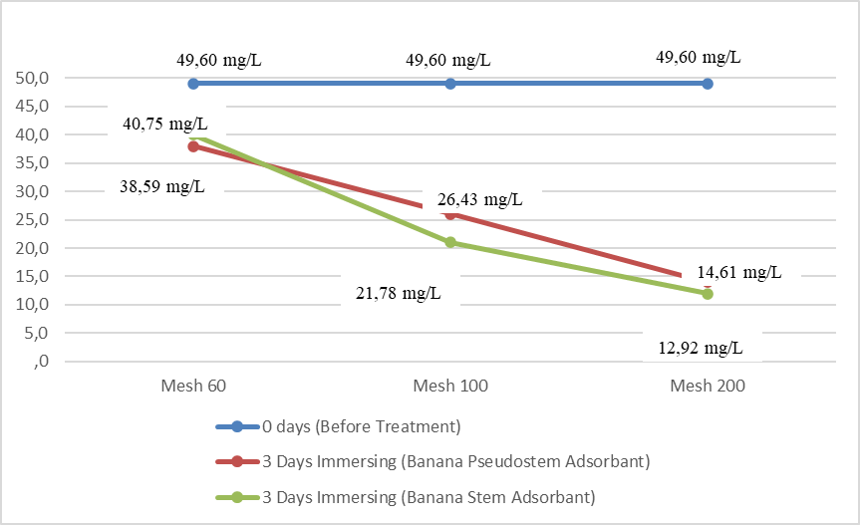

**Graphic 2.** Results of Peroxide Absorption in Used Cooking Oil with Banana Pseudostem and Banana Stem Adsorbents

The statistical analysis of FFA content using Paired Sample T-Test, the results are considered effective if the P*value* is < 0.05 is presents in table 1.

**Table 1.** Analysis of Free Fatty Acid Content in Used Cooking Oil Using Banana Pseudostem and Banana Stem Adsorbents



From Table 1, a significant difference in the average FFA content was observed, the statictical test yielded a significance value of 0.03, indicating a significant diference in FFA levels before and after immersion with banana pseudostem and banana stem.

**Table 2.** Analysis of Peroxide Content in Used Cooking Oil Using Banana Pseudostem and Banana Stem Adsorbents



From table 2 indicate that, while there was reduction in the peroxide value of the used cooking oil treatment with banana pseudostem and banana stems adsorbents, this reduction was not statistically significant. This means the the observed changes might not highly effective in reducing peroxide levels or their effect is marginal.

**DISCUSSION**

**Free Fatty Acids (FFA) Value**

The research results indicate that adsorbnets dervied from banana pseudostem and banana stem, with particle size of 60 mesh, 100 mesh and 200 mesh, effectively reduced the free fatty acid (FFA) content in used cooking oil sourced from a local food vendor. This efficiency is likely attributed to the high cellulose and glucose contents present in banana pseudostem and banana stem. According to SNI 01-3741-2002, the maximum permissible FFA level is 0.3%, and the adsorbents in this research succesfully reduced the FFA levels to below this standard. Among the adsorbents types, banana pesudostem was the most effective and the 200-mesh size was the most efficeinet, achieving up to a 70% reduction in FFA content.

This research result demonstrates that the particle size of the adsorbent significantly influences its adsorption efficiency. Several factors affect the adsorption rate and the amount of adsorbate that adsorbents can absorb.

These findings align with previous research that the potential of banana-based adsorbent in reducing FFA level in used cooking oil. For instance (14) investigated the isotherm adsoption in FFA in waste cooking oil using activated carbon derived form banana peel biomass that found that activated carbon from banana peel effectively adsorbed FFAs.

Similarly, (15) examined the potential of Musa acuminata balbisiana Colla in reducing FFA levels in used cooking oil, showed a significant decrease in FFA content after treatment with banana peel powder, suggesting its efficacy as a natural adsorbent improving the quality of used cooking oil.

A recent study by (16) examined the use of activated charcoal derived from Leucaena leucophala wood is significantly reduce FFA content in UCO in 1,5 hours.

This aligns (17), these factors include the adsorbent’s surface area, particle size, and chemical composition, with specific surface area and particle size being the most dominant factors.

As noted (18), smaller adsorbent garnules provide a larger surface area, enabling better absorption of contaminants. Generally, adsorption speed is determined by the rate at which solutes transfer into the pores of the adsorbent particles.

This finding aligns with research (6), which demonstrated that banana stems are effctive in reducing FFA content in used cooking oil due to their high cellulose and lignin content.

This reasearch found, banana pseudostems and stems, especially at finer particle sizes, serve as effective natural adsorbents for reducing FFA and peroxide values in used cooking oil. However, to meet stringent quality standards, further treatment or activation of these adsorbents may be necessary to enhance their adsorption capabilities. This also found that banana pseudostem was the most effective part of banana plant for adsorption than banana stem. This effectiveness is hypothesized to results form differences in pore density and cellulose and lignin content between the pseudosetem and stem parts.

**Peroxide Value**

The results of this study demonstrate the efficacy of banana stem adsorbent (200-mesh) in reducing the peroxide value of the used cooking oil. The peroxide value significantly decreased from an initial 49.60 mg/L to 12.92 mg/L following treatment, representing a reduction of approximately 74%. The banana pseudostem, after being immersed for three days (3x24 hours), showed a reduction in peroxide value to 14.61 mg/L , achieving a 75% decrease in peroxide content. Although, banana pesudostem and banana stem adsorbent effectively lowered the peroxide content, the final values still exceeded the permissible limit set by SNI 01-3741-2002, which is 1.00 mg/L. It is indicating that the current treatment is not sufficient to achive the desired peroxide reduction.

The reduction in peroxide values can be attributed to the high cellulose content found in both banana pseudostem and stem, which plays significant role in adsorbing and neutralizing peroxides. Cellulose, being a highly polar substance, can adsorb organic compounds such as peroxides, thus reducing their concentration in the oil. Studies have shown that adsorbents with high cellulose content, such as various plant materials, can be effective in lowering peroxide levels in oils (19,20).

The high cellulose content in banana pseudostem and stem contributed to the reduction in peroxide levels. However, further improvements are neceesary to achive peroxide levels below the permissible treshold.

However, while the treatment resulted in a substantial reduction, it did not achieve the required threshold for edible oils as stipulated by the SNI 01-3741-2002 standard. This suggest that further optimization of the process is necessary. Potential improvements could include extending the treatment duration, modifying the adsorbent size, or using additional material to enhance the adsorption capacity (18). Additionally, other factor such as temperature, pH, and oil type may also play a role in improving the effectiveness of the treatment (21).

Enhancing peroxide reduction might involve incorporating additional substance or employing alternative methods. For example, converting banana pseudostem and banana stem into activaded carbon treated with chemical activators such as sulfuric acid (H₂SO₄), hydrochloric acid (HCl), or phosphoric acid (H₃PO₄), could improve adsoption capacity (22).

Aligns to (23), that using activated Ampo as an adsorbent reduced peroxide values in used cooking oil by 93%, meeting standard quality requirements.

But this methods have weakness, they reduces the eco-friendly nature of the adsorbent derived from banana pseudostems and stems by introducing non-biodegradable chemicals. So it’s recommended to longer immersion times, higher adsorbent quantities of banana pseudostem and banana stem adsorbents.

According to (21), the activation time also affects the adsorbent’s quality; longer activation times allow for better removal of organic matter blocking the pores.

In the context of used cooking oil treatment, optimizing the activation time of adsorbents like banana pseudostem and banana stem could lead to more efficient reduction of peroxide values. By extending the activation duration, it is possible to achieve a more thorough removal of organic impurities, thereby improving the adsorbent’s performance in purifying used cooking oil.

This study found that the decrease of FFA more significant that peroxide due to chemical composition and adsorption mechanism in UCO. FFAs are the result of hydrolysis of triglycerides during frying, leading to their accumulation in UCO. Natural adsorbent, such as banana pseudostems and stems, are rich in cellulose and lignin, which have a strong affinity for polar compounds like FFAs. This affinity facilitates the adsorption of FFAs more effectively than peroxides. In contrast, peroxides are formed through the oxidation of lipids and may not interact as readily with the functional groups present in natural adsorbents (25).

It highlight to optimizing particle size and controlling lignin content are critical for maximizing the adsorption capacity of banana pseudostems and stems, ensuring effective reduction od FFA and peroxide values in UCO.

**CONCLUTION**

The particle of banana pseudostem and banana stem affect the effectiveness of reducing peroxide and Free fatty Acid (FFA) levels in used cooking oil. Adsorbents with a particle size of 200 mesh show the best efficiency, with banana pseudostems performing slightly better than banana stems. This study demonstrate the great potential of banana pseudostems and banana stems as inexpensive and environmentally friendly natural adsorbent materials for used cooking oil.

**ACKNOWLEDGEMENT**

We extend our gratitude STIKes Tengku Maharatu for funding this research on Penelitian Dosen Pemula internal grand the realization of this research. May this study provide meaningful contributions to the field and inspire further advancements in eco-friendly and sustainable solutions.

**REFERENCES**

1. Kemenperin R. Business Report No . : 74. Indones Commer Newsl [Internet]. 2022;Business R. Available from: ISSN 0853-2086

2. Tri Yulianto, Rhevi HS Putri, Nur Khotimah. Analisis Pengaruh Harga Cpo (Crude Palm Oil) Dunia Dan Produksi Cpo (Crude Palm Oil) Indonesia Terhadap Fluktuasi Harga Minyak Goreng Curah Indonesia. Jurnal Cakrawala Ilmiah. 2022; Vol 2 No 2, page 741–748.

3. Devianti VA, Arifiyana D. Analysis of the Quality of Waste Cooking Oil Resulted from Rejuvenation Using Raja Nangka Banana Peel Adsorbent with Variations in Mass of Adsorbent and Length of Adsorption Time. Walisongo Journal of Chemistry. 2023; Vol 6 Issue 2, pages 181–187.

4. Kusumaningtyas RD, Qudus N, Putri RDA, Kusumawardani R. Penerapan Teknologi Pengolahan Limbah Minyak Goreng Bekas Menjadi Sabun Cuci Piring Untuk Pengendalian Pencemaran Dan Pemberdayaan Masyarakat. Jurnal Abdimas. 2018;22(2):201–218.

5. Endi Kusnadi. Studi Potensi Pencemaran Lingkungan Akibat Limbah Minyak Jelantah Di Kota Banda Aceh. 2018;

6. Hasyim UH, Kurniaty I, Mahmudah H, Hermanti M. Pengaruh Waktu Adsorpsi Asam Lemak Bebas dalam Minyak Kelapa Sawit Mentah pada Pembuatan Bioadsorben Limbah Batang Pisang. Jurnal Konversi. 2019;8(1):61–70.

7. Inayati NI, Dhanti KR. Pemanfaatan Minyak Jelantah Sebagai Bahan Dasar Pembuatan Lilin Aromaterapi Sebagai Alternatif Tambahan Penghasilan Pada Anggota Aisyiyah Desa Kebanggan Kec Sumbang. Budimas Jurnal Pengabdian Masyarakat. 2021;3(1):160–6.

8. Udyani K, Purwaningsih DY, Setiawan R, Yahya K. Pembuatan Karbon Aktif dari Arang Bakau Menggunakan Gabungan Aktivasi Kimia dan Fisika dengan Microwave. Jurnal IPTEK. 2019;23(1):39–46.

9. Zou F, Tan C, Zhang B, Wu W, Shang N. The Valorization of Banana By-Products: Nutritional Composition, Bioactivities, Applications, and Future Development. jurnal Foods. 2022;11(20).

10. Rosentrater KA, Persyn R, Todey D. Quantifying total and sustainable agricultural biomass resources in South Dakota. 2007 ASABE Annu Int Meet Tech Pap. 2007;14 Book (May).

11. Deshmukh DGM, Sawarkar HA, Varu TD. Banana Pseudo-Stem : an Alternative Raw Material for Paper Making. International Journal of Engineering Applied Science and Technology. 2019. Vol 4 issue 4, pages 68–73.

12. Badanayak P, Jose S, Bose G. Banana pseudostem fiber: A critical review on fiber extraction, characterization, and surface modification. Journal Nat Fibers [Internet]. 2023;20(1).

13. Untung Waluyo, Aldi Ramadhani, Alvina Suryadinata, Lia Cundari. Review: penjernihan minyak goreng bekas menggunakan berbagai jenis adsorben alami. Jurnal Teknik Kimia. 2020; Vol 26 No2 pages 70–79.

14. Rengga WDP, Seubsai A, Roddecha S, Yudistira A, Wiharto AD. Isotherm adsorption of free fatty acid in waste cooking oil used activated carbon of banana peel as bio-adsorbent. Journal of Physics : Conference Series. 2021;1918(3).

15. Kartikorini N, Kunsah B, Ariana D, Damayanti S. The Potential of Banana kepok (Musa acuminata balbisiana Colla) skin on free fatty acid levels in oil. Research Journal of Pharmacy and Technology. 2023;Vol 16 Issue 1, pages:129–132.

16. Muhammad HN, Nikmah F, Hidayah NU, Haqiqi AK. Arang Aktif Kayu Leucaena Leucocephala sebagai Adsorben Minyak Goreng Bekas Pakai (Minyak Jelantah). Physics Education Research Journal. 2020; Vol 2 Issue 2, pages:123-130.

17. Meila Anggriani U, Hasan A, Purnamasari I, Tekn. Kinetika Adsorpi Karbon Aktif dalam Penurunan Konsentrasi Logam Tembaga (Cu) dan Timbal (Pb). Polteknik Negeri SUrabaya. Jurnal Kinetika. 2021; Vol 12 No 02, pages : 29–37.

18. Vidia Amelia K, Tuslinah L, Yuliana A. Pengaruh Ukuran Partikel Bioadsorben Akar Alang-Alang (Imperata cylindrica L) Terhadap Kualitas Minyak Jelantah the Influence of the Size of the Bioadsorbent of Reeds Imperata cylindrica L to the Quality of Used Cooking Oil. Jurnal Kesehatan Bakti Tunas Husada. 2023; Vol 23 No(2), pages 1–13.

19. Musyarrofah S, Jannah A. The Effectiveness of Activated Carbon as an Adsorbent in Reducing Acid and Peroxide Levels in the Refining of Rice Bran Oil (Oryza sativa L.). Multidiscipline-International Conference. International Standard of Serial Number Conference Proceeding. 2023;171–177.

20. Karić N, Maia AS, Teodorović A, Atanasova N, Langergraber G, Crini G, et al. Bio-waste valorisation: Agricultural wastes as biosorbents for removal of (in)organic pollutants in wastewater treatment. Chemical Engineering Journal Advance. 2022;9(December); 100239.

21. Wannahari, R., & MFN, Nordin. Reduction of Peroxide Value in Used Palm Cooking Oil Using Bagasse Adsorbent. American International Journal Contemporary Research. 2012; Vol 2 Issue 1, pages:185–191.

22. Sabzehmeidani MM, Mahnaee S, Ghaedi M, Heidari H, Roy VAL. Carbon based materials: A review of adsorbents for inorganic and organic compounds. Material Advance Journal. 2021; Vol 2(2):598–627.

23. S. Susilowati, Astya KL, Bachri US. Reducing Peroxide Value In Used Cooking Oil Using Ampo As An Adsorbent. Internatuonal Journal Eco-Innovation in Science and Engineering. 2021; Vol 2(02) pages:1–8.

24. Poon S. Symbolic Resistance: Tradition in Batik Transitions Sustain Beauty, Cultural Heritage and Status in the Era of Modernity. World Journal Social Science. 2020;7(2):1.

25. Onn M, Muniandy K, Zaiton SNA, Wahit MU. Free Fatty Acid Reduction in Used Frying Oil via Bio Adsorbent: A Short Review. Chemical Engineering Transactions. 2023; Vol 106(August):139–144.